Unsupervised Learning

What is clustering?

A clustering algorithm looks at

a number of data points and

automatically finds data points that are

related or similar to each other.

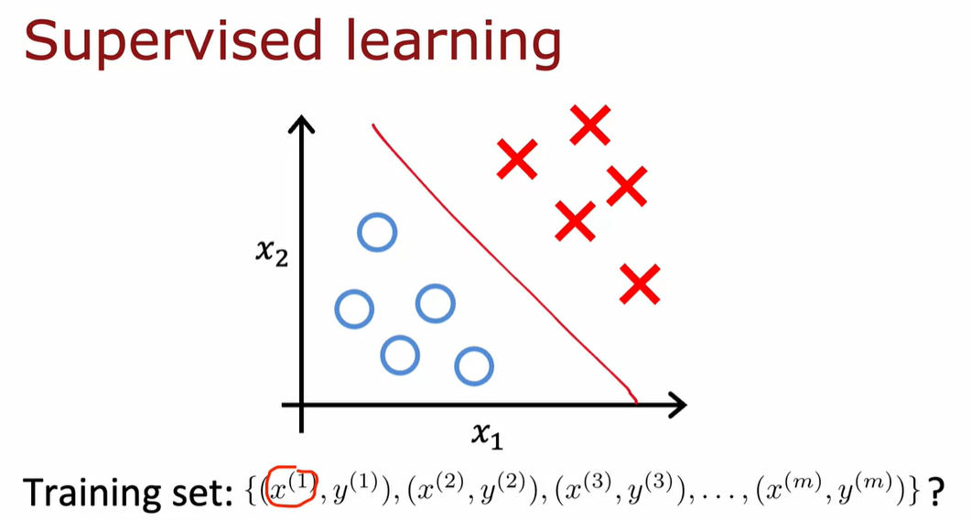

Let's take a look at what that means.

Let me contrast clustering,

which is an unsupervised learning algorithm,

with what you had previously seen with

supervised learning for binary classification.

Given a dataset like this with features x_1 and x_2.

With supervised learning, we had a training set with both

the input features x as well as the labels y.

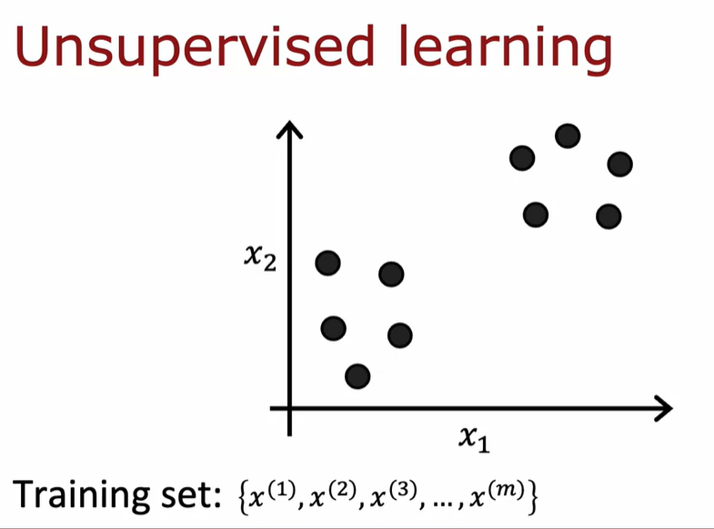

In contrast, in unsupervised learning,

you are given a dataset like this with just x,

but not the labels or the target labels y.

That's why when I plot a dataset,

it looks like this,

with just dots rather than two classes

denoted by the x's and the o's.

Because we don't have target labels y,

we're not able to tell

the algorithm what is the "right answer,

y" that we wanted to predict.

Instead, we're going to ask the algorithm to

find something interesting about the data,

that is to find some interesting

structure about this data.

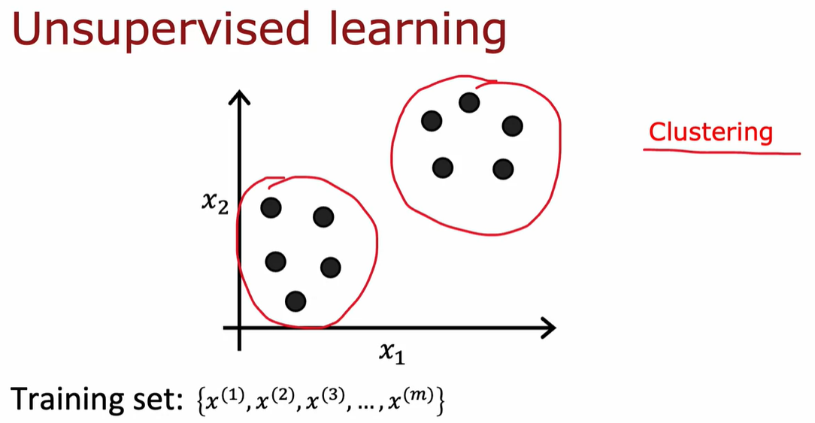

But the first unsupervised learning algorithm

that you learn about is called a clustering algorithm,

which looks for one particular type

of structure in the data.

Namely, look at the dataset like this and try to

see if it can be grouped into clusters,

meaning groups of points that are similar to each other.

A clustering algorithm, in this case,

might find that this dataset

comprises of data from two clusters shown here.

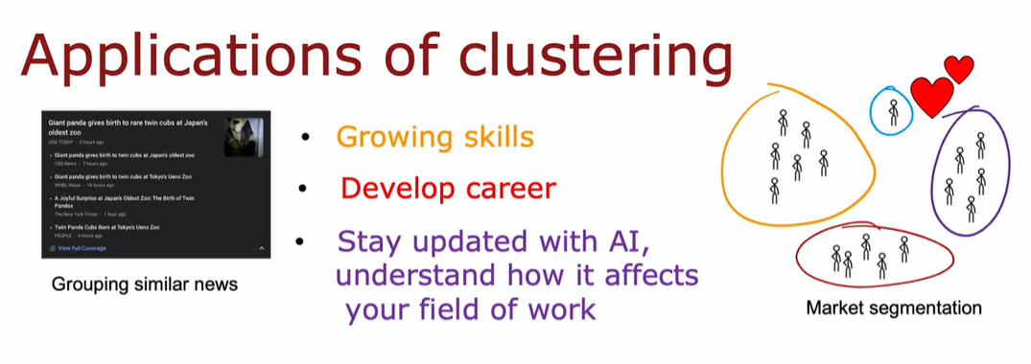

Here are some applications of clustering.

In the first week of the first course,

you heard me talk about

grouping similar news articles together,

like the story about Pandas or market segmentation,

where at deeplearning.ai,

we discovered that there are many learners that come

here because you may want to grow your skills,

or develop your careers,

or stay updated with

AI and understand how it affects your field of work.

We want to help everyone with any of

these skills to learn about machine learning,

or if you don't fall into one of these clusters,

that's totally fine too.

I hope deeplearning.ai and

Stanford Online's materials will

be useful to you as well.

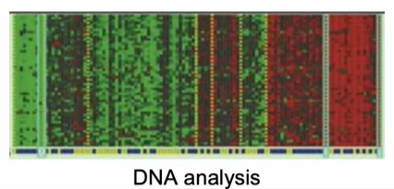

Clustering has also been used to analyze DNA data,

where you will look at the genetic expression data from

different individuals and try to group them

into people that exhibit similar traits.

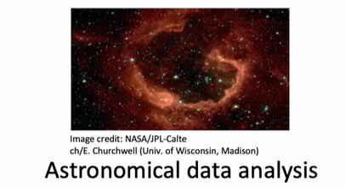

I find astronomy and space exploration fascinating.

One application that I thought was very

exciting was astronomers using

clustering for astronomical data analysis to

group bodies in space together for

their own analysis of what's going on in space.

One of the applications I found

fascinating was astronomers using

clustering to group bodies together to figure out which

ones form one galaxy or

which one form coherent structures in space.

# Video K-Means Intuition

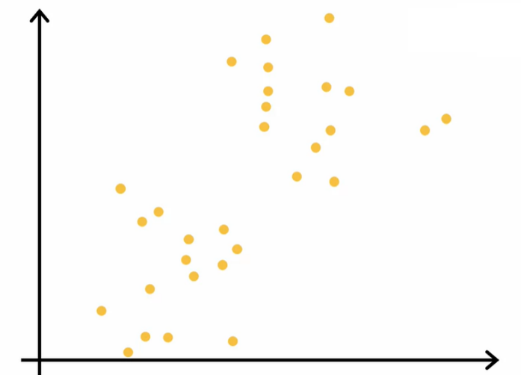

Here I've plotted a data set with 30 unlabeled training examples.

So there are 30 points.

And what we like to do is run K-means on this data set.

The first thing that the K-means algorithm does is it will take a random guess

at where might be the centers of the two clusters that you might ask it to find.

In this example I'm going to ask it to try to find two clusters.

Later in this week we'll talk about how

you might decide how many clusters to find.

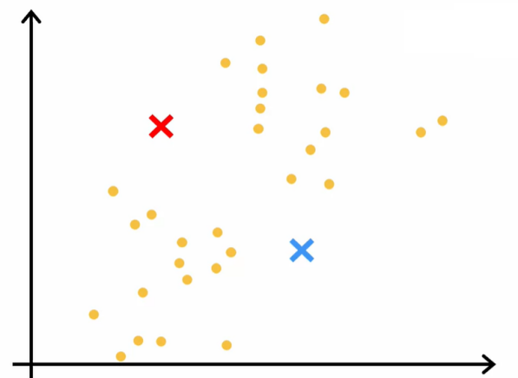

But the very first step is it will randomly pick two points,

which I've shown here as a red cross and the blue cross,

at where might be the centers of two different clusters.

This is just a random initial guess and they're not particularly good guesses.

But it's a start.

One thing I hope you take away from this video is that K-means will

repeatedly do two different things.

The first is assign points to cluster centroids and

the second is move cluster centroids.

Let's take a look at what this means.

The first of the two steps is it will go through each of these points and

look at whether it is closer to the red cross or to the blue cross.

The very first thing that K-means does is it will take a random guess

at where are the centers of the cluster?

And the centers of the cluster are called cluster centroids.

After it's made an initial guess at where the cluster centroid is,

it will go through all of these examples, x(1) through x(30), my 30 data points.

And for each of them it will check if it is closer to the red cluster centroid,

shown by the red cross, or if it's closer to the blue cluster centroid,

shown by the blue cross

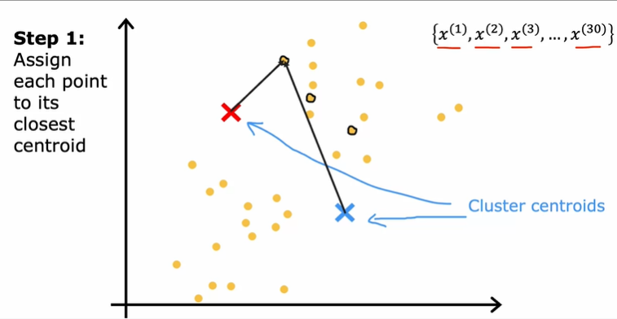

I'm going to illustrate that by painting each of these examples,

each of these little round dots, either red or blue, depending on

whether that example is closer to the red or to the blue cluster centroid.

So this point up here is closer to the red centroid, which is why it's painted red

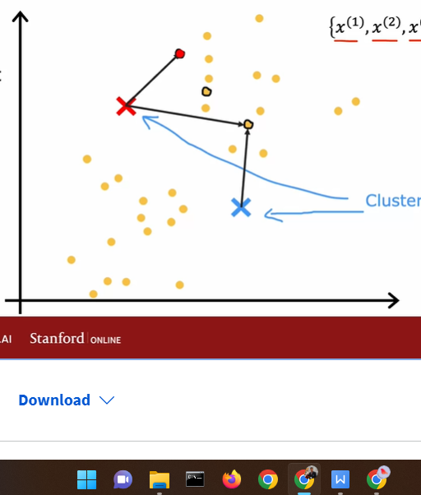

Whereas this point down there is closer to the blue cluster centroid,

which is why I've now painted it blue.

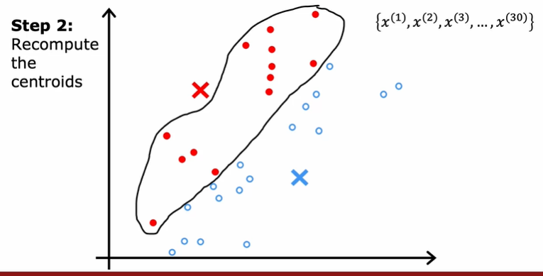

The second of the two steps that K-means does is,

it'll look at all of the red points and take an average of them.

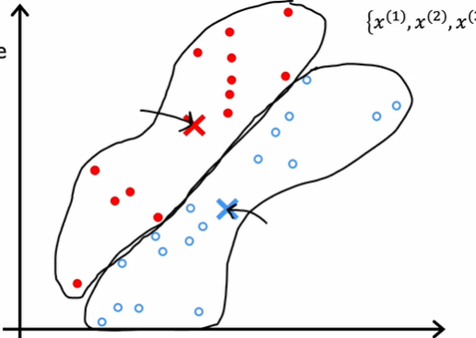

And it will move the red cross to whatever is the average

location of the red dots, which turns out to be here.

And so the red cross, that is the red cluster centroid will move here.

And then we do the same thing for all the blue dots.

Look at all the blue dots, and take an average of them, and

move the blue cross over there.

So you now have a new location for the blue cluster centroid as well.

WE HAVE ILUSTRATION HOW TO KMEAN WORK, watching again the video

Untuk have convergent average mean

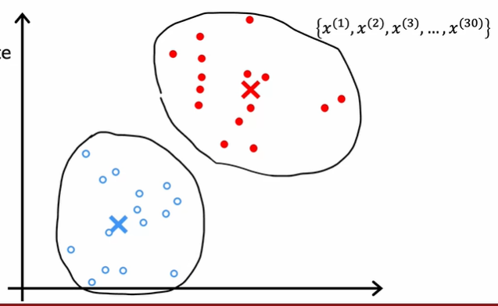

# Video K-Means Algorithm

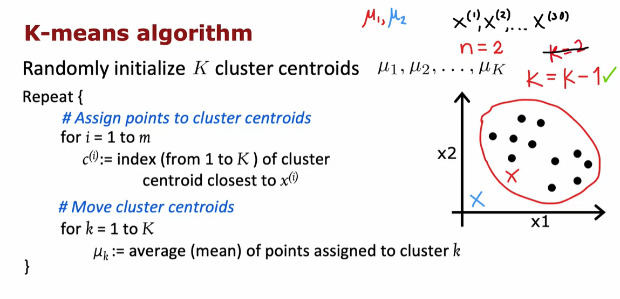

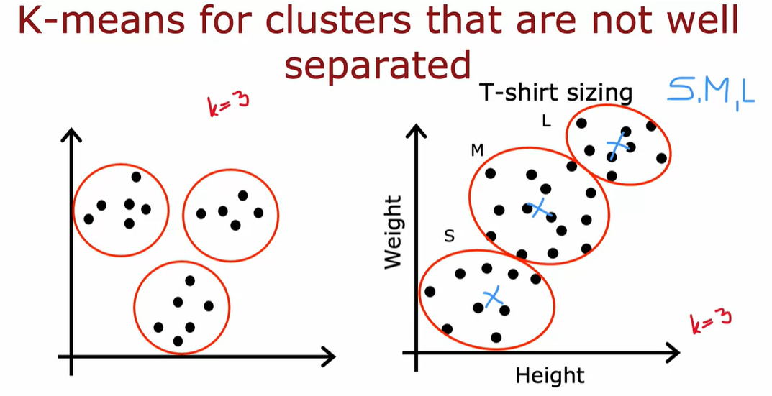

# Video Optimization Objective

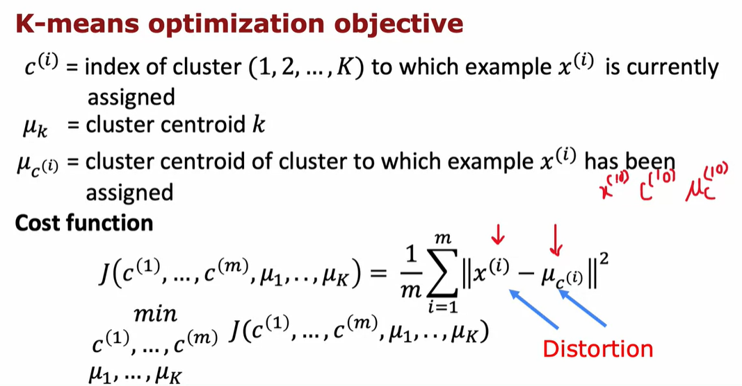

Let's take a look at what is the cost function for a means

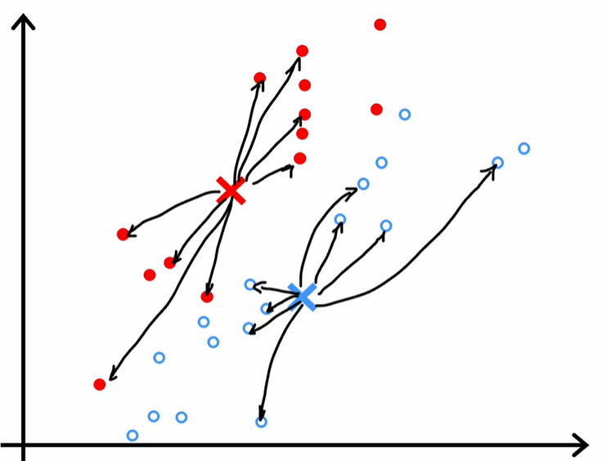

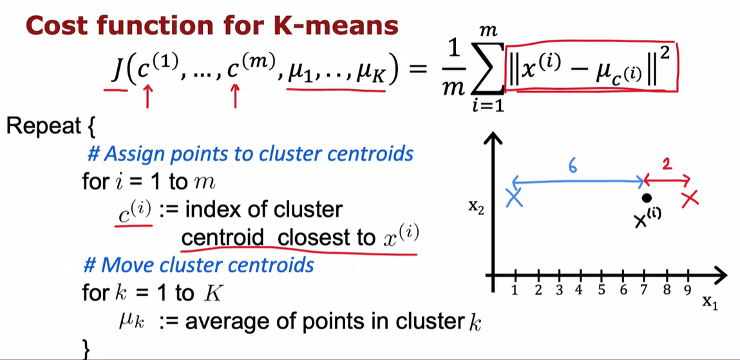

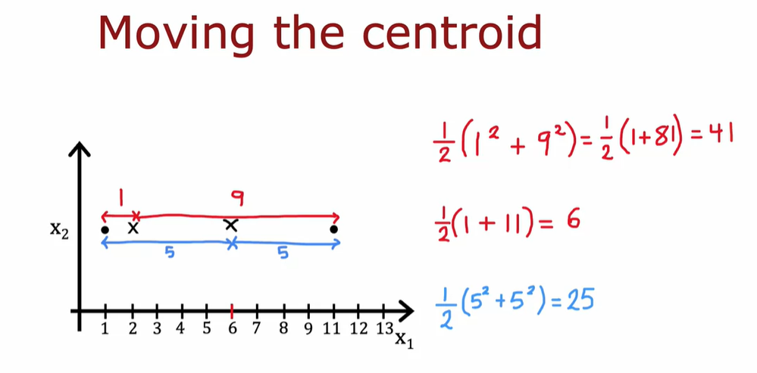

# Video Initialization K-Means

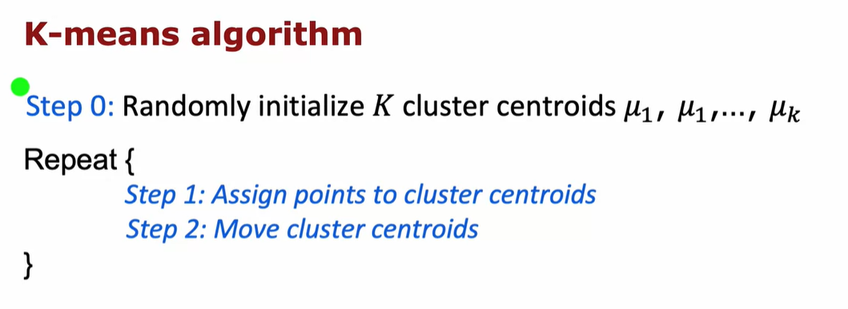

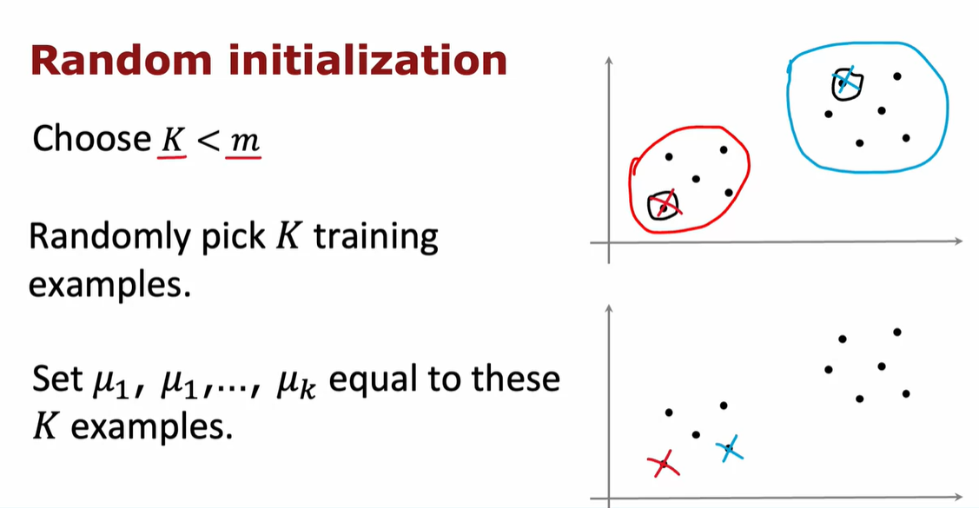

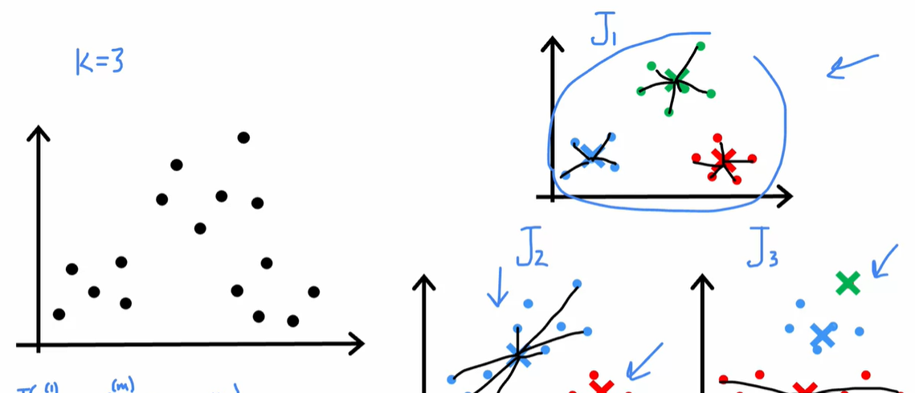

# Video Choosing the number of cluster

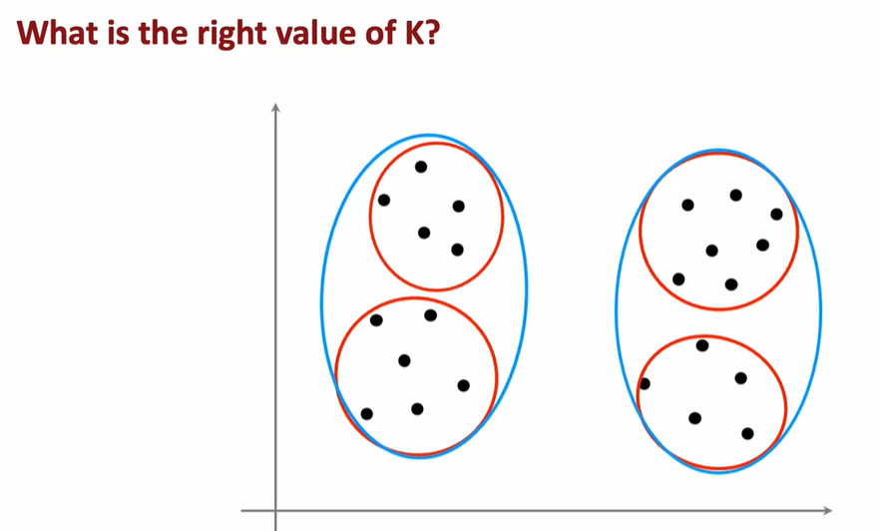

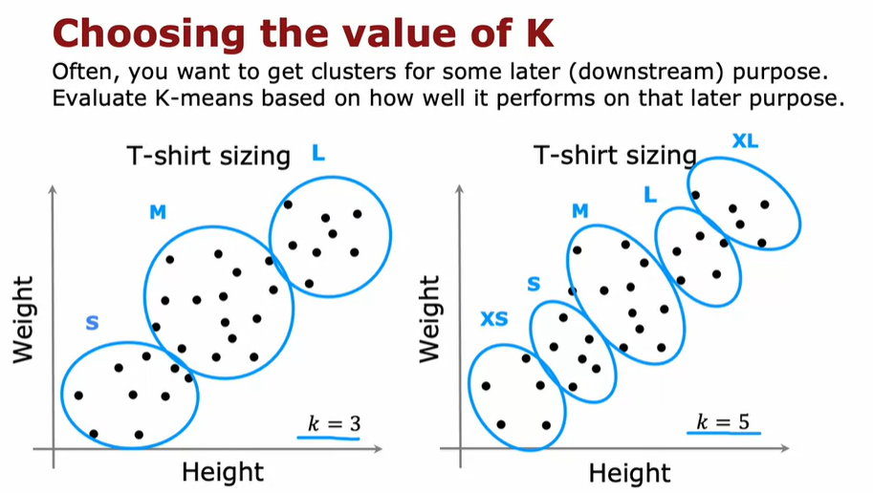

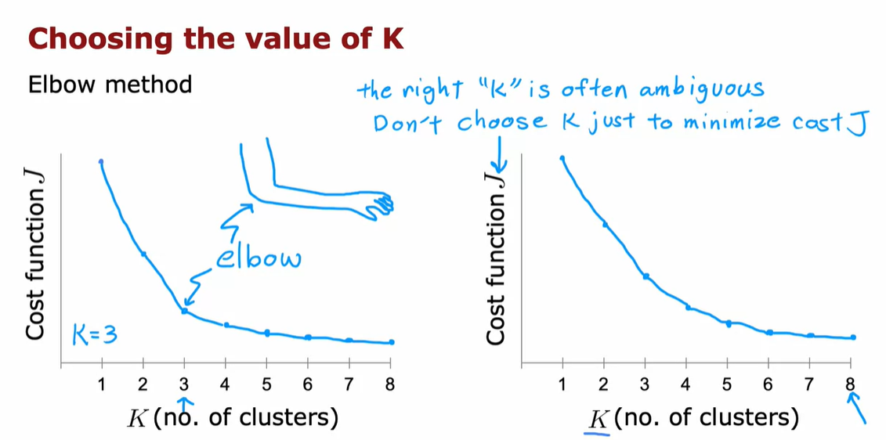

################################ Anomaly Detection ################################

# Video finding unusual events

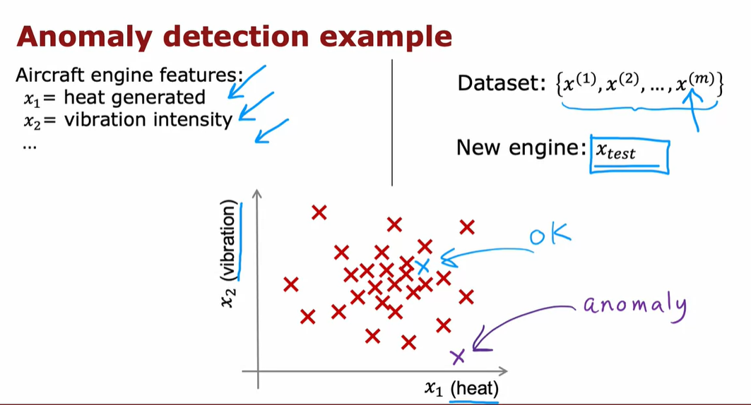

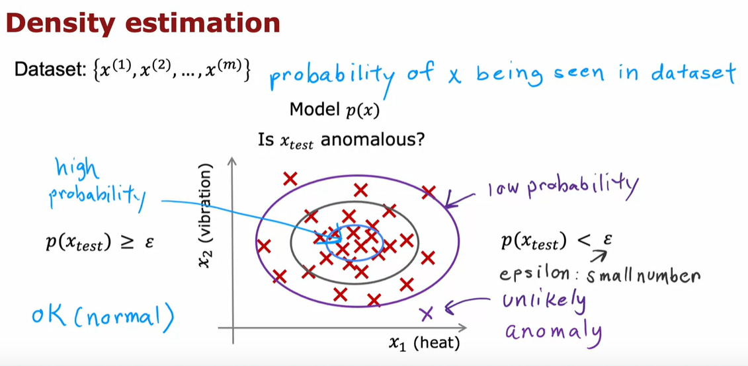

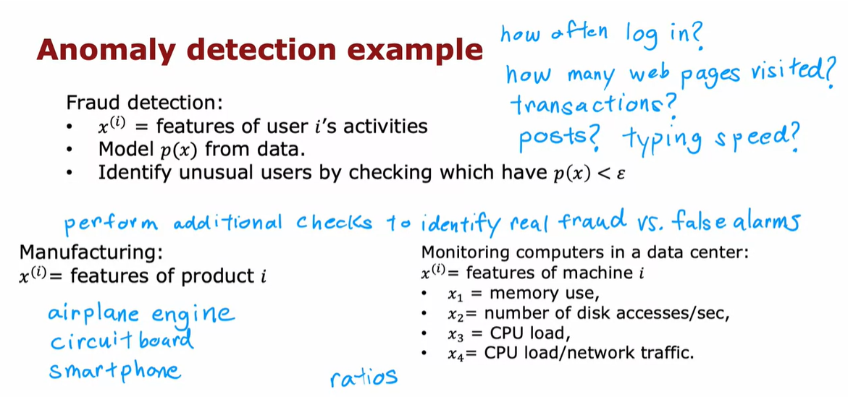

# Video Gaussian (normal) Distribution

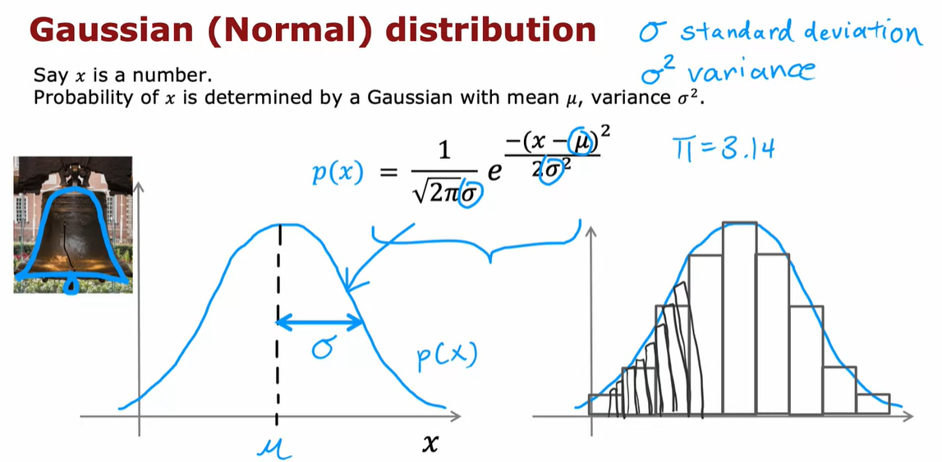

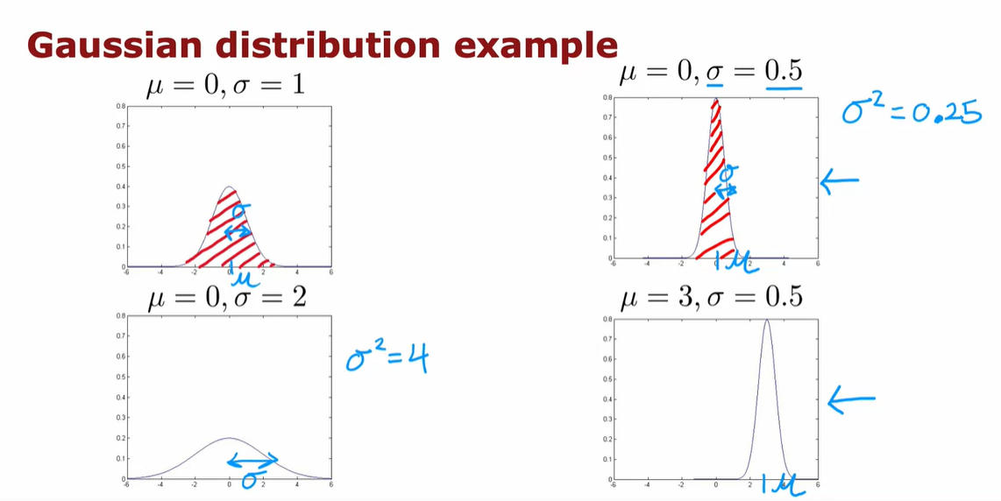

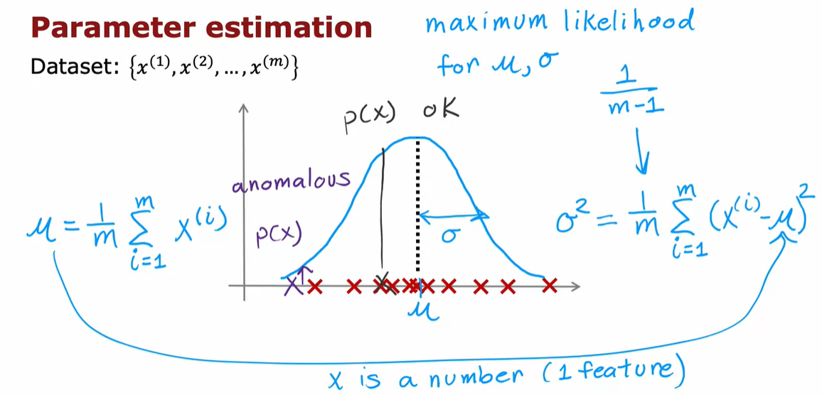

# Video Anomaly Detection

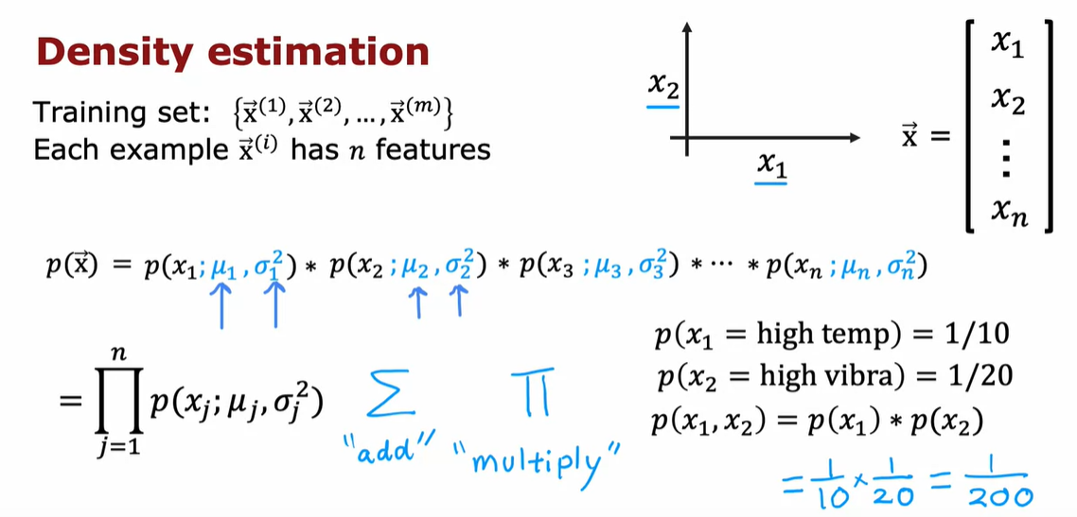

Now that you've seen how the Gaussian or the normal distribution works for

a single number, we're ready to build our anomaly detection algorithm.

Let's dive in.

You have a training set x1 through xm,

where here each example x has end features.

So, each example x is a vector within numbers.

In the case of the airplane engine example,

we had two features corresponding to the heat and the vibrations.

And so, each of these excise would be a two dimensional vector and

n would be equal to 2.

But for many practical applications n can be much larger and

you might do this with dozens or even hundreds of features.

Given this training set, what we would like to do is to carry

out density estimation and all that means is,

we will build a model or estimate the probability for p(x).

What's the probability of any given feature vector?

And our model for p(x) is going to be as follows,

x is a feature vector with values x1, x2 and so on down to xn.

And I'm going to model p(x) as the probability of x1,

times the probability of x2,

times the probably of x3 times the probability of xn,

for the n th features in the feature vectors.

If you've taken an advanced class in probably in statistics before,

you may recognize that this equation corresponds to assuming that

the features x1, x2 and so on up to xm are statistically independent.

But it turns out this algorithm often works fine even that the features

are not actually statistically independent.

But if you don't understand what I just said, don't worry about it.

Understanding physical independence is not needed to fully complete discuss and

also, be able to very effectively use anomaly detection algorithm.

Now, to fill in this equation a little bit more,

we are saying that the probability of all the features of this vector features x,

is the product of p(x) 1 and p(x2) and so on up through p(xn).

And in order to model the probability of x1,

say the heat feature in this example we're going to have two parameters,

new 1 and sigma 1 or sigma squared is 1.

And what that means is we're going to estimate, the mean of the feature x1 and

also the variance of feature x1 and that will be new 1 and sigma 1.

To model p(x2) x2 is a totally different

feature measuring the vibrations of the airplane engine.

We're going to have two different parameters,

which I'm going to write as mu 2, sigma 2 squared.

And it turns out this will correspond to the mean or the average of

the vibration feature and the variance of the vibration feature and so on.

If you have additional features mu 3 sigma 3

squared up through mu n and sigma n squared.

In case you're wondering why we multiply probabilities,

maybe here's 1 example that could build intuition.

Suppose for an aircraft engine there's a 1/10

chance that it is really hot, unusually hot and

maybe there is a 1 in 20 chance that it vibrates really hard.

Then, what is the chance that it runs really hot and vibrates really hard.

We're saying that the chance of that is 1/10 times 1/20 which is 1/200.

So it's really unlikely to get an engine that both fronts really hot and

vibrates really hard.

It's the product of these two probabilities

A somewhat more compact way to write this equation up here,

Play video starting at :4:23 and follow transcript4:23

is to say that this is equal to,

the product from j =1 through n of p(xj).

Would parameters mu j and sigma squared j.

And this symbol here is a lot like the summation symbol except that

whereas the summation symbol corresponds to addition, this

symbol here corresponds to multiplying these terms over here for j =1 through n.

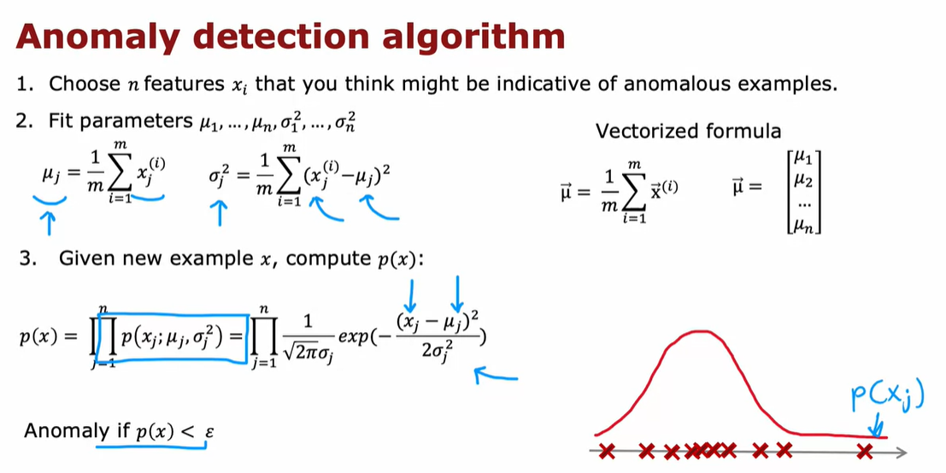

So let's put it all together to see how you can build in

the nominee detection system.

The first step is to choose features xi that you

think might be indicative of anomalous examples.

Having come up with the features you want to use,

you would then fit the parameters mu 1 through mu n and

sigma square 1 through sigma squared n, for the n features in your data set.

As you might guess, the parameter mu j will be just the average

of xj of the feature j of all the examples in your training set.

And sigma square j will be the average of the square

difference between the feature and the value mu j,

that you just computed.

And by the way, if you have a vectorized implementation,

you can also compute mu as the average of the training examples as follows,

we're here, x and mu are both vectors.

And so this would be the vectorized way of computing mu 1 through mu and

all at the same time.

And by estimating these parameters on your unlabeled training set,

you've now computed all the parameters of your model.

Finally, when you are given a new example, x test or

I'm just going to write a new example as x here,

what you would do is compute p(x) and see if it's large or small.

So p(x) as you saw on the last slide is the product from j = 1 through

n of the probability of the individual features.

So p(x) j with parameters mu j and single square j.

And if you substitute in, the formula for this probability, you end

up with this expression 1 over root 2 pi sigma j of e to this expression over here.

And so xj are the features, this is a j feature of your new example,

mu j and sigma j are numbers or parameters you have computed in the previous step.

And if you compute out this formula, you get some number for p(x).

Play video starting at :7:19 and follow transcript7:19

And the final step is to see a p(x) is less than epsilon.

And if it is then you flag that it is an anomaly.

Play video starting at :7:29 and follow transcript7:29

1 intuition behind what this album is doing is that it will tend to

flag an example as anomalous if 1 or more of the features are either very large or

very small relative to what it has seen in the training set.

So for each of the features x j, you're fitting a Gaussian distribution like this.

And so if even 1 of the features of the new example was

way out here, say, then P f xJ would be very small.

And if just 1 of the terms in this product is very small, then this overall product,

when you multiply together will tend to be very small and does p(x) will be small.

And what anomaly detection is doing into the algorithm is

a systematic way of quantifying whether or not this new example x

has any features that are unusually large or unusually small.

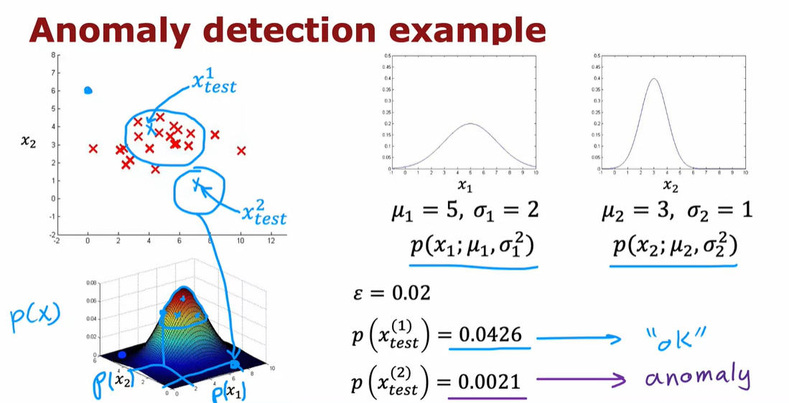

Now, let's take a look at what all this actually means on 1 example,

Here's the data set with features x 1 and x 2.

Play video starting at :8:39 and follow transcript8:39

And you notice that the features x 1 take on a much larger range

of values than the features x 2.

Play video starting at :8:48 and follow transcript8:48

If you were to compute the meme of the Features x 1, you end up with five,

which is why you want is equal to 1.

And it turns out that for this data said, if you compute sigma 1,

it will be equal to about 2.

And if you were to compute mu to the average of the features on next

to the average is three and similarly is variance or

standard deviation is much smaller, which is why Sigma 2 is equal to 1.

So that corresponds to this Gaussian distribution for

x 1 and this Gaussian distribution for x 2.

If you were to actually multiply p(x) 1 and p(x) 2,

then you end up with this three D surface plot for p(x) where any point,

the height of this is the product of p(x) 1 times p(x) 2.

For the corresponding values of x 1 and x 2.

And this signifies that values where p(x) is higher or more likely.

So, values near the middle kind of here are more likely.

Whereas values far out here, values out here are much less likely.

I have much lower chance.

Play video starting at :10:5 and follow transcript10:05

Now, let me pick to test examples, the first 1 here,

I'm going to write this x test 1 and the second 1 down here as x test 2.

And let's see which of these 2 examples the album will flag as anomalous.

Play video starting at :10:22 and follow transcript10:22

I'm going to pick The Parameter ε to be equal to 0.02.

And if you were to compute p(x) test 1,

it turns out to be about 0.4 and this is much bigger than epsilon.

And so the album will say this looks okay, doesn't look like an anomaly.

Whereas in contrast, if you were to compute p(x) for

this point down here corresponding to x 1 equals about eight and

x 2 equals about 0.5.

Play video starting at :10:58 and follow transcript10:58

Kind of down here, then p(x) test 2 is 0.0021.

So this is much smaller than epsilon.

And so the album will flag this as a likely anomaly.

So, pretty much as you might hope it decides that x test 1 looks pretty normal.

Whereas excess to which is much further away than anything you see in the training

set looks like it could be an anomaly.

So you've seen the process of how to build an anomaly detection system.

But how do you choose the parameter epsilon?

And how do you know if your anomaly detection system is working well in

the next video, let's dive a little bit more deeply into the process of

developing and evaluating the performance of an anomaly detection system.

# Video Developing and Evaluating an anomaly detection system

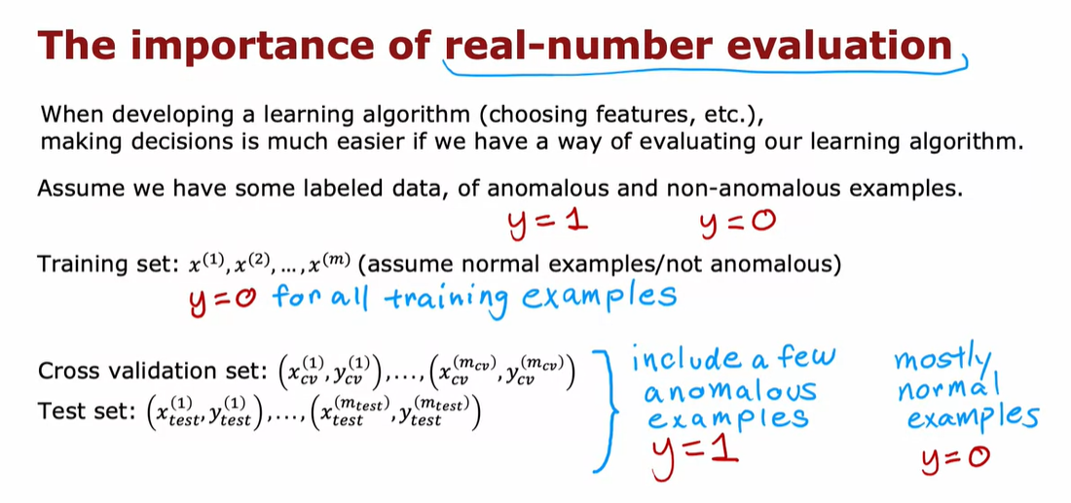

I'd like to share with you some practical tips for

developing an anomaly detection system.

One of the key ideas will be that if you

can have a way to evaluate a system,

even as it's being developed,

you'll be able to make decisions and change

the system and improve it much more quickly.

Let's take a look at what that means.

When you are developing a learning algorithm,

say choosing different features or trying

different values of the parameters like epsilon,

making decisions about whether or not to change

a feature in a certain way or to

increase or decrease epsilon or other parameters,

making those decisions is much easier if you have

a way of evaluating the learning algorithm.

This is sometimes called real number evaluation,

meaning that if you can

quickly change the algorithm in some way,

such as change a feature or change

a parameter and have a way of

computing a number that tells

you if the algorithm got better or worse,

then it makes it much easier to decide

whether or not to stick

with that change to the algorithm.

This is how it's often done in anomaly detection.

Which is, even though we've mainly

been talking about unlabeled data,

I'm going to change that assumption a bit

and assume that we have some labeled data,

including just a small number

usually of previously observed anomalies.

Maybe after making airplane engines for a few years,

you've just seen a few airplane engines

that were anomalous,

and for examples that you know are anomalous,

I'm going to associate a label y

equals 1 to indicate this anomalous,

and for examples that we think are normal,

I'm going to associate the label y equals 0.

The training set that

the anomaly detection algorithm will learn from is

still this unlabeled training set of x1 through xm,

and I'm going to think of all of these examples

as ones that we'll just

assume are normal and not anomalous,

so y is equal to 0.

In practice, you have

a few anomalous examples

where to slip into this training set,

your algorithm will still usually do okay.

To evaluate your algorithm,

come up with a way for you

to have a real number evaluation,

it turns out to be very useful if you have a small number

of anomalous examples so

that you can create a cross validation set,

which I'm going to denote x_cv^1,

y_cv^1 through x_cv^mcv, y_cv^mcv.

This is similar notation as you had

seen in the second course of this specialization.

As similarly, have a test set

of some number of examples where

both the cross validation and test sets hopefully

includes a few anomalous examples.

In other words, the cross validation and test sets will

have a few examples of y equals 1,

but also a lot of examples where y is equal to 0.

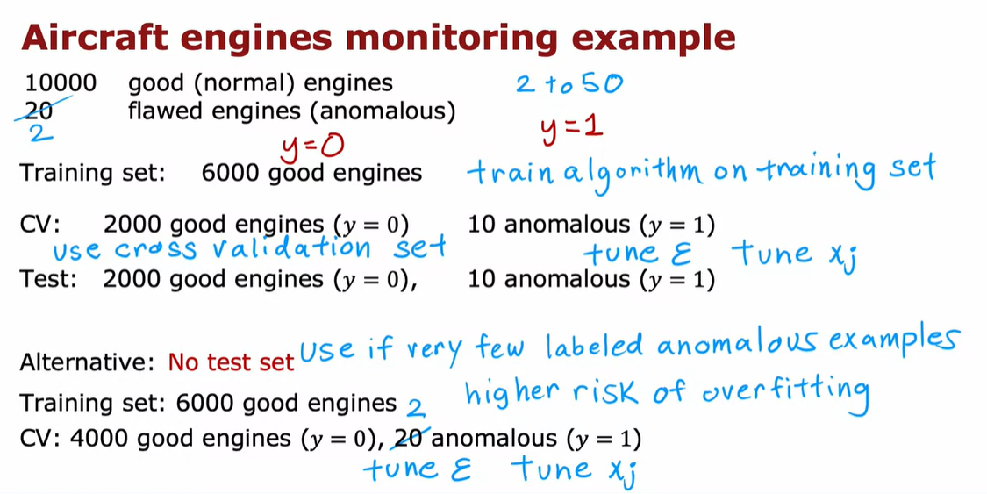

Again, in practice,

anomaly detection algorithm will work okay if

there are some examples that are actually anomalous,

but there were accidentally labeled with y equals 0.

Let's illustrate this with the aircraft engine example.

Let's say you have been manufacturing

aircraft engines for years and so you've

collected data from 10,000 good or normal engines,

but over the years you had also collected data

from 20 flawed or anomalous engines.

Usually the number of anomalous engines,

that is y equals 1,

will be much smaller.

It will not be a typical to

apply this type of algorithm with anywhere from,

say, 2-50 known anomalies.

We're going to take this dataset and

break it up into a training set,

a cross validation set,

and the test set. Here's one example.

I'm going to put 6,000

good engines into the training set.

Again, if there are couple of anomalous engines

that got slipped into this set is actually okay,

I wouldn't worry too much about that.

Then let's put 2,000 good engines and

10 of the known anomalies into the cross-validation set,

and a separate 2,000 good and 10

anomalous engines into the test set.

What you can do then is

train the algorithm on the training set,

fit the Gaussian distributions to these 6,000 examples

and then on the cross-validation set,

you can see how many of

the anomalous engines it correctly flags.

For example, you could use the cross validation set

to tune the parameter epsilon and set it

higher or lower depending

on whether the algorithm seems to be reliably

detecting these 10 anomalies without taking too

many of these 2,000 good

engines and flagging them as anomalies.

After you have tuned the parameter epsilon and

maybe also added or subtracted or

tuned to features X_J you can then take the algorithm and

evaluate it on your test set to see

how many of these 10 anomalous engines it finds,

as well as how many mistakes it makes by

flagging the good engines as anomalous ones.

Notice that this is still

primarily an unsupervised learning algorithm

because the training sets really has no labels or

they all have labels that we're assuming to

be y equals 0 and so we

learned from the training set by fitting

the Gaussian distributions as

you saw in the previous video.

But it turns out if you're building

a practical anomaly detection system,

having a small number of anomalies to use to evaluate

the algorithm that your cross validation and test

sets is very helpful for tuning the algorithm.

Because the number of flawed engines is so small there's

one other alternative that I often see

people use for anomaly detection,

which is to not use a test set,

like to have just a training set

and a cross-validation set.

In this example, you will set

train on 6,000 good engines,

but take the remainder of the data,

the 4,000 remaining good

engines as well as all the anomalies,

and put them in the cross validation set.

You would then tune the parameters Epsilon

and add or subtract fictious x_j to try to

get it to do as well as possible

as evaluated on the cross validation set.

If you have very few flawed engines,

so if you had only two flawed engines,

then this really makes sense to

put all of that in the cross validation set.

You just don't have enough data to create

a totally separate test set

that is distinct from your cross-validation set.

The downside of this alternative

here is that after you've tuned your algorithm,

you don't have a fair way to tell how well

this will actually do on

future examples because you don't have the test set.

But when your dataset is small,

especially when the number of anomalies you have,

your dataset is small,

this might be the best alternative you have.

I see this done quite often as well when

you just don't have enough data

to create a separate test set.

If this is the case,

just be aware that there's

a higher risk that you will have

over-fit some of your

decisions around Epsilon and choice of features

and so on to the cross-validation set

and so its performance on

real data in the future may not

be as good as you were expecting.

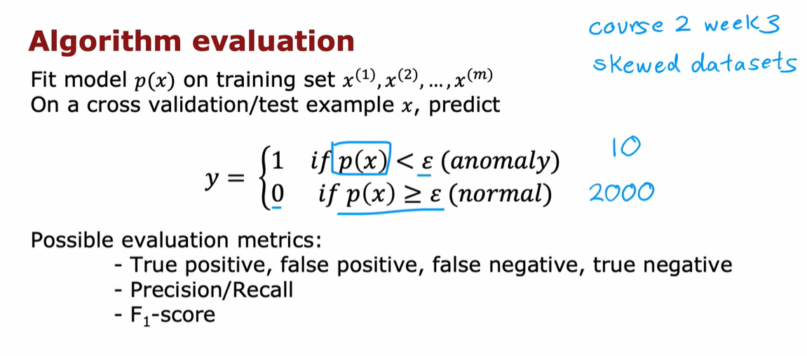

Now, let's take

a closer look at how to actually evaluate

the algorithm on your cross-validation sets or

on the test set. Here's what you'd do.

You would first fit the model p of x on the training set.

This was a 6,000 examples of goods engines.

Then on any cross validation or test example x,

you would compute p of x and you will predict y equals 1.

That is anomalous if p of x is

less than Epsilon and you predict y is 0,

if p of x is greater than or equal to Epsilon.

Based on this, you can now look at how accurately

this algorithm's predictions on

the cross validation or test set matches the labels,

y you have in the cross validation or the test sets.

In the third week of the second course,

we had had a couple of optional videos on how to handle

highly skewed data distributions

where the number of positive examples,

y equals 1, can be much smaller than

the number of negative examples where y equals 0.

This is the case as well for

many anomaly detection in the applications where

the number of anomalies in

your cross-validation set is much smaller.

In our previous example,

we had maybe 10 positive examples and 2,000

negative examples because we had

10 anomalies and 2,000 normal examples.

If you saw those optional videos,

you may recall that we saw it can

be useful to compute things like the true positive,

false positive, false negative,

and true negative [inaudible].

Also compute precision recall or

F_1 score and that these are alternative metrics and

classification accuracy that could work

better when your data distribution is very skewed.

If you saw that video,

you might consider applying those types of

evaluation metrics as well to tell how well

your learning algorithm is doing at finding

that small handful of anomalies or

positive examples amidst this much larger set

of negative examples of normal plane engines.

If you didn't watch that video,

don't worry about it. It's okay.

The intuition I hope you get

is to use the cross-validation set to just look at

how many anomalies is finding and also

how many normal engines is

incorrectly flagging as an anomaly.

Then to just use that to try to

choose a good choice for the parameter Epsilon.

You find that the practical process

of building an anomaly detection system is much

easier if you actually have

just a small number of

labeled examples of known anomalies.

Now, this does raise the question,

if you have a few labeled examples,

since you'll still be using

an unsupervised learning algorithm,

why not take those labeled examples

and use a supervised learning algorithm instead?

In the next video, let's take a look

at a comparison between

anomaly detection and supervised learning

and when you might prefer one over the other.

# Video Anomaly Detection Vs Supervised Learning

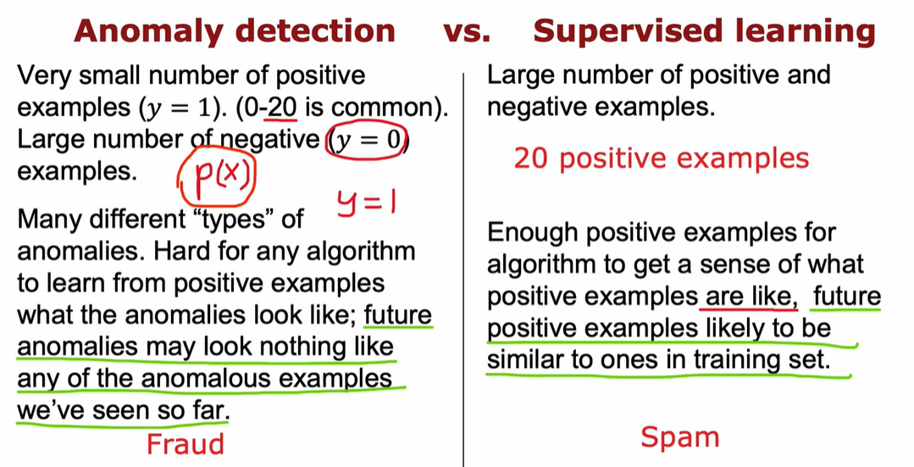

When you have a few positive examples with Michael's 1 and

a large number of negative examples say y = 0?

When should you use anomaly detection and when should you use supervised learning?

The decision is actually quite subtle in some applications.

So let me share with you some thoughts and some suggestions for

how to pick between these two types of algorithms.

And anomaly detection algorithm will typically be the more appropriate

choice when you have a very small number of positive examples,

0-20 positive examples is not uncommon.

And a relatively large number of negative examples

with which to try to build a model for p of x.

When you recall that the parameters for

p of x are learned only from the negative examples and this much smaller.

So the positive examples is only used in your cross validation set and

test set for parameter tuning and for evaluation.

In contrast, if you have a larger number of positive and

negative examples, then supervised learning might be more applicable.

Now, even if you have only 20 positive training examples,

it might be okay to apply a supervised learning algorithm.

But it turns out that the way anomaly detection looks at the data set

versus the way supervised learning looks at the data set are quite different.

She is the main difference, which is that if you think there are many

different types of an obvious or many different types of positive examples.

Then anomaly detection might be more appropriate when there

are many different ways for an aircraft engine to go wrong.

And if tomorrow there may be a brand new way for

an aircraft engine to have something wrong with it.

Then your 20 say positive examples may not cover all of the ways that

an aircraft engine could go wrong.

That makes it hard for any algorithm to learn from the small set of

positive examples what the anomalies, what the positive examples look like.

And future anomalies may look nothing like any

of the anomalous examples we've seen so far.

If you believe this to be true for your problem,

then I would gravitate to using an anomaly detection algorithm.

Because what anomaly detection does is it looks at the normal examples that

is the y = 0 negative examples and just try to model what they look like.

And anything that deviates a lot from normal It flags as an anomaly.

Including if there's a brand new way for

an aircraft engine to fail that had never been seen before in your data set.

In contrast, supervised learning has a different way of looking at the problem.

When you're applying supervised learning ideally you would hope to have

enough positive examples for

the average to get a sense of what the positive examples are like.

And with supervised learning, we tend to assume that the future positive

examples are likely to be similar to the ones in the training set.

So let me illustrate this with one example,

if you are using a system to find, say financial fraud.

There are many different ways unfortunately that

some individuals are trying to commit financial fraud.

And unfortunately there are new types of

financial fraud attempts every few months or every year.

And what that means is that because they keep on popping up completely new.

And unique forms of financial fraud anomaly detection is often used to just

look for anything that's different, then transactions we've seen in the past.

In contrast, if you look at the problem of email spam detection, well,

there are many different types of spam email, but even over many years.

Spam emails keep on trying to sell similar things or

get you to go to similar websites and so on.

Spam email that you will get in the next few days is much more likely

to be similar to spam emails that you have seen in the past.

So that's why supervised learning works well for

spam because it's trying to detect more of the types of spam

emails that you have probably seen in the past in your training set.

Whereas if you're trying to detect brand new types of fraud that have never been

seen before in the nominate section, maybe more applicable.

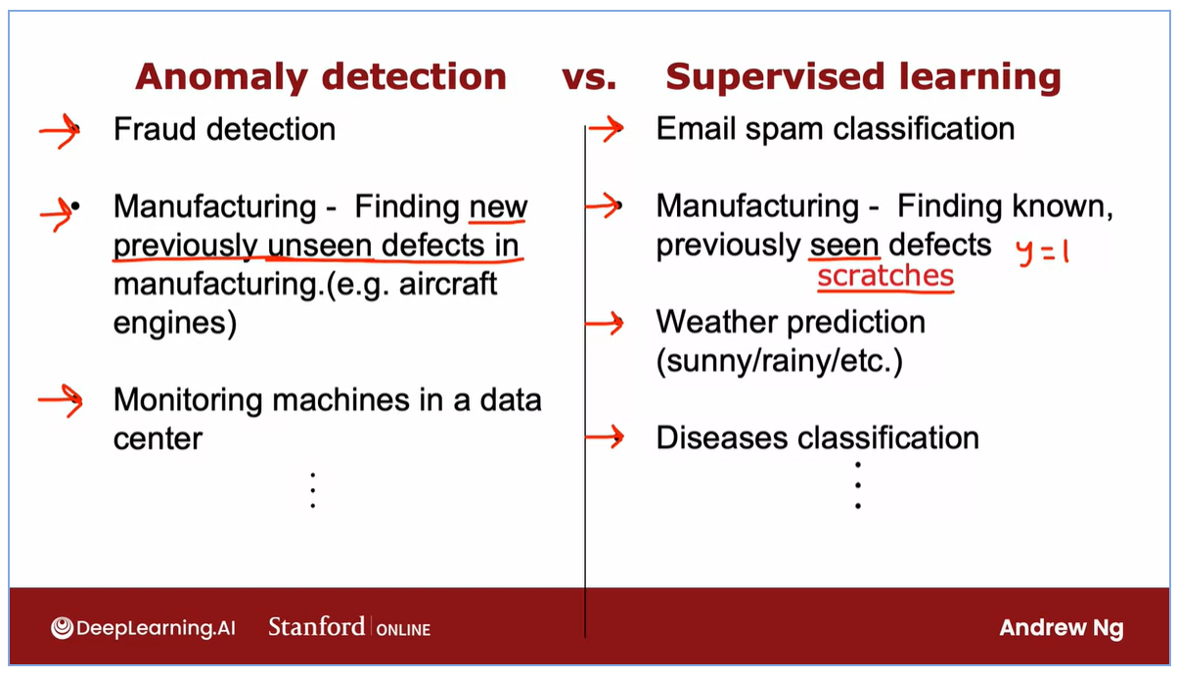

Let's go through a few more examples.

We have already seen fraud detection being one use case of anomaly detection.

Although supervised learning is used to find previously observed forms of fraud.

And we've seen email spam classification typically being address

using supervised learning.

You've also seen the example of manufacturing where

you may want to find new previously unseen defects.

Such as if there are brand new ways for

an aircraft engine to fail in the future that you still want to detect.

Even if you don't have any positive example like that in your training set.

It turns out that the manufacturing supervised learning is also used to find

defects.

The more for finding known and previously seen defects.

For example, if you are a smartphone maker, you're making cell phones.

And you know that occasionally your machine for

making the case of the smartphone will accidentally stretch the cover.

So stretches are a common defect on smartphones and so you can get

enough training examples of stretched smartphones responding to label y =1.

And just train the system to decide if a new smartphone that you just

manufactured has any stretches in it.

And the difference is if you just see stretch smartphones over and over and

you want to check if your phones are stretched,

then supervised learning works well.

Whereas if you suspect that they're going to be brand new ways for

something to go wrong in the future, then anomaly detection will work well.

Some other examples you've heard me talk about monitoring machines in the data

center, especially the machine's been hacked.

It can behave differently in a brand new way unlike any previous way in his

behavior.

So that would feel more like an anomaly detection application.

In fact, one theme is that many security related applications because

hackers are often finding brand new ways to hack into systems.

Many security related applications will use anomaly detection.

Whereas returning to supervised learning, if you want to learn to predict

the weather well, there's only a handful types of weather that you typically see.

Is it sunny, rainy, is it going to snow?

And so because you see the same output labels over and over,

weather prediction would tend to be a supervised learning task.

Or if you want to use the symptoms of the patient to see if the patient has

a specific disease that you've seen before.

Then that would also tend to be a supervised learning application.

So I hope that gives you a framework for deciding when you have a small set of

positive examples as well as maybe a large set of negative examples.

Whether to use anomaly detection or supervised learning.

Anomaly detection tries to find brand new positive examples that may be unlike

anything you've seen before.

Where supervised learning looks at your positive examples and

tries to decide if a future example is similar to the positive examples that

you've already seen.

Now, it turns out that when building an anomaly detection algorithm, the choice

of features is very important and when building anomaly detection systems.

I often spend a bit of time trying to tune the features I use for

the system in the next video.

# Video Choosing what features to use

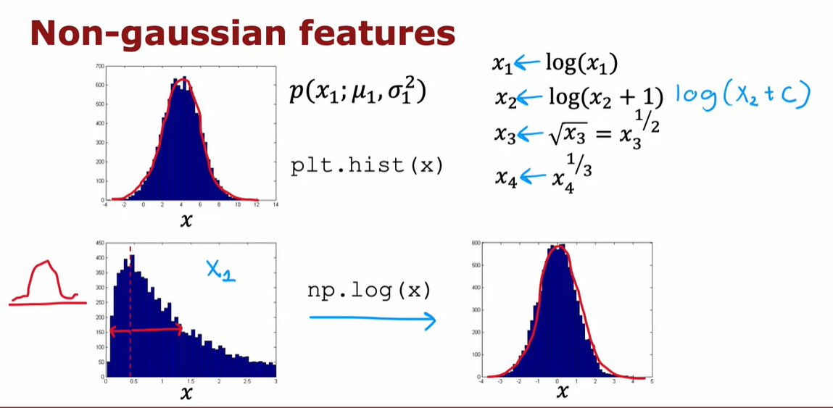

When building an anomaly detection algorithm,

I found that choosing a good choice of features turns out to be really important.

In supervised learning, if you don't have the features quite right, or

if you have a few extra features that are not relevant to the problem,

that often turns out to be okay.

Because the algorithm has to supervised signal that is enough labels why for

the algorithm to figure out what features ignore, or how to re scale feature and

to take the best advantage of the features you do give it.

But for anomaly detection which runs, or learns just from unlabeled data,

is harder for the anomaly to figure out what features to ignore.

So I found that carefully choosing the features, is even more important for

anomaly detection, than for supervised learning approaches.

Let's take a look at this video as some practical tips, for how to tune

the features for anomaly detection, to try to get you the best possible performance.

One step that can help your anomaly detection algorithm,

is to try to make sure the features you give it are more or less Gaussian.

And if your features are not Gaussian,

sometimes you can change it to make it a little bit more Gaussian.

Let me show you what I mean.

If you have a feature X, I will often plot to hissed

a gram of the feature which you can do using the python command PLT.

Though you see this in the practice lab as well,

in order to look at the history graham of the data.

This distribution here looks pretty Gaussian.

So this would be a good candidate feature.

If you think this is a feature that hopes distinguish between anomalies and

normal examples.

But quite often when you plot a hissed a gram of your features,

you may find that the feature has a distribution like this.

This does not at all look like that symmetric bell shaped curve.

When that is the case, I would consider if you can take this feature X,

and transform it in order to make a more Gaussian.

For example, maybe if you were to compute the log of X and

plot a hissed a gram of log of X, look like this, and

this looks much more Gaussian.

And so if this feature was feature X one, then instead of using the original

feature X one which looks like this on the left, you might instead replace

that feature with log of X one, to get this distribution over here.

Because when X one is made more Gaussian.

When anomaly detection models P of X one using a Gaussian

distribution like that, is more likely to be a good fit to the data.

Other than the log function, other things you might do is, given

a different feature X two, you may replace it with X two, log of X two plus one.

This would be a different way of transforming X two.

And more generally, log of X two plus C, would be one example of

a formula you can use, to change X to try to make it more Gaussian.

Or for a different feature, you might try taking the square root or

really the square would have executed this X lead to the power of

one half,and you may change that exponentially term.

So for a different feature X four,

you might use X four to the power of one third, for example.

So when I'm building an anomaly detection system,

I'll sometimes take a look at my features, and if I see any highly non Gaussian

by plotting hissed a gram, I might choose transformations like these or

others, In order to try to make it more Gaussian.

It turns out a larger value of C, will end up transforming this distribution less.

But in practice I just try a bunch of different values of C,

and then try to take a look to pick one that looks better in terms of making

the distribution more Gaussian.

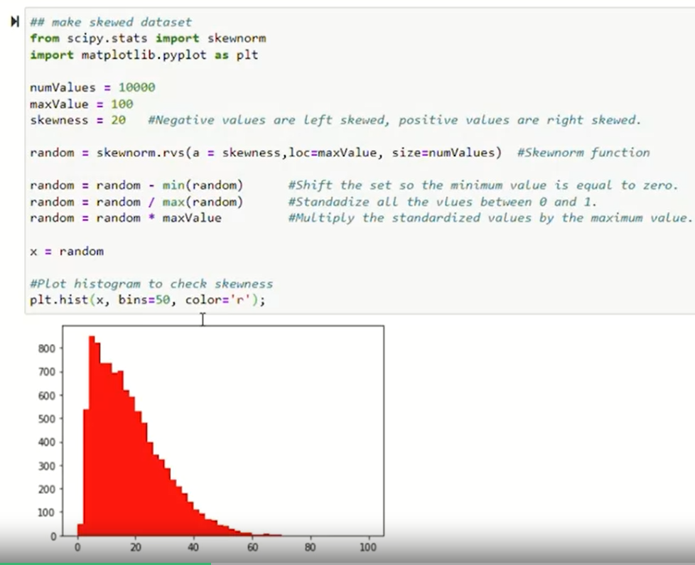

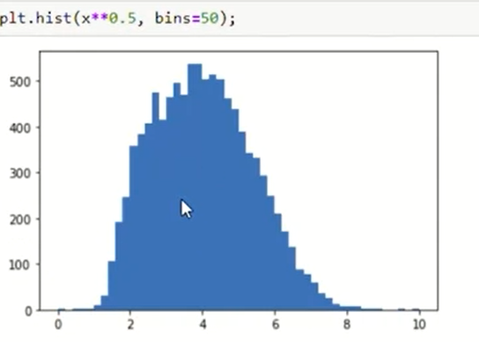

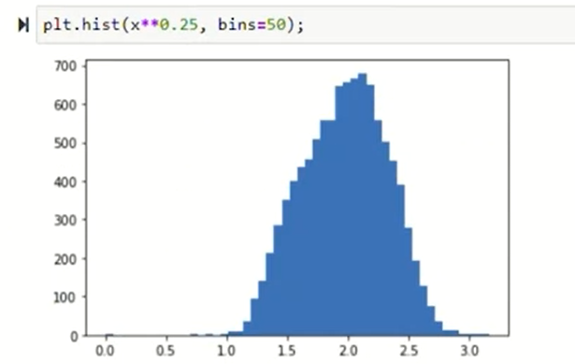

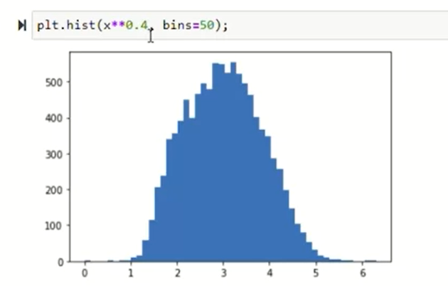

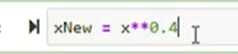

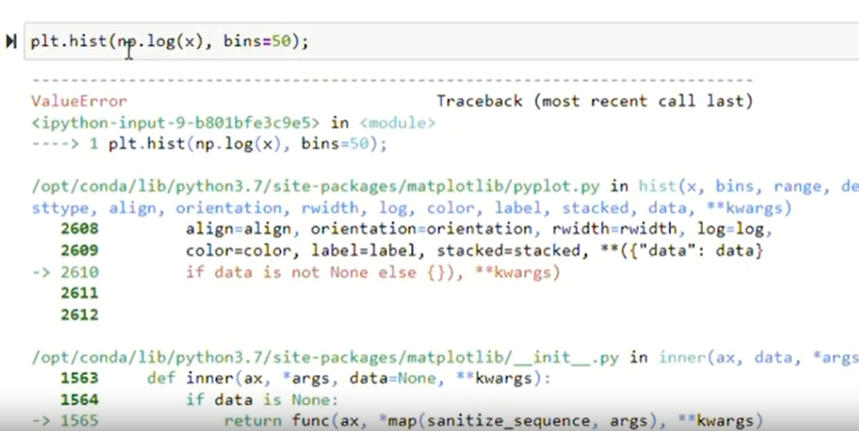

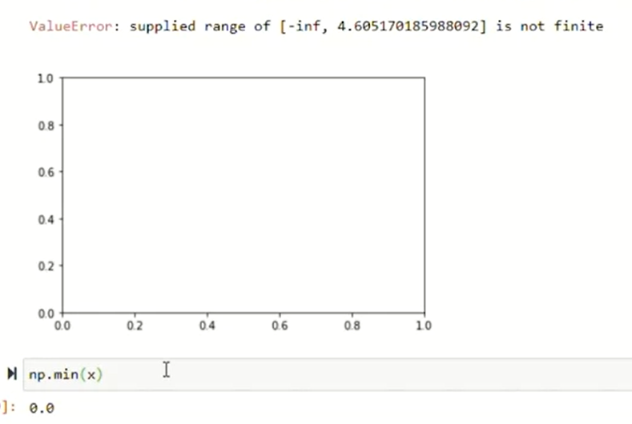

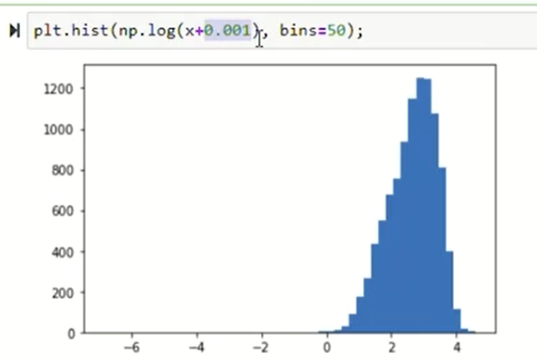

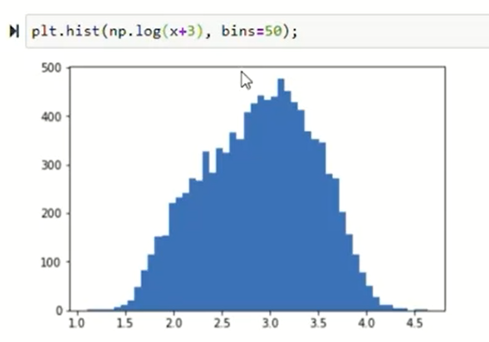

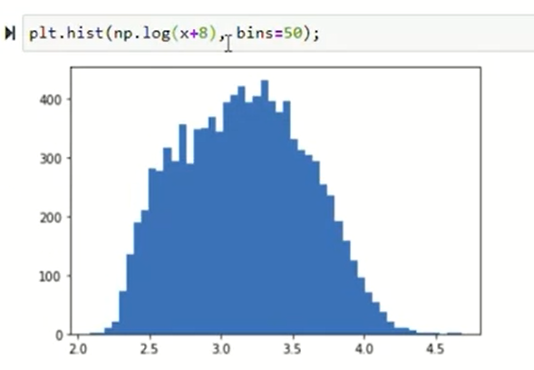

When you have a feature X, you can plot a hissed a gram of it as follows.

It actually looks like there's a pretty cause hissed a gram.

Let me increase the number of bins in my history gram to 50.

So bins equals 50 there.

That's what hissed a gram bins.

And by the way, if you want to change the color, you can also do so as follows.

And if you want to try a different transformation,

you can try for example to plot X square root of X.

So X to the power of 0.5 with again 50 hissed a gram bins,

in which case it might look like this.

And this actually looks somewhat more Gaussian.

But not perfectly, and let's try a different parameter.

So let me try to the power of 4.25.

Maybe I just a little bit too far.

It's the old 0.4 that looks pretty Gaussian.

So one thing you could do is replace X with excellent power of 0.4.

And so you would set X to be equal to X to the power of 0.4.

And just use the value of X in your training process instead.

Or let me show you another transformation.

Here, I'm going to try taking the log of X.

So log of X spotted with 50 bins,

I'm going to use the numpy log function as follows.

And it turns out you get an error, because it turns out that excellent.

This example has some values that are equal to zero, and

we'll log of zero is negative infinity is not defined.

So common trick is to add just a very tiny number there.

Play video starting at :6:28 and follow transcript6:28

So exports 0.001, becomes non negative.

And so you get the hissed gram that looks like this.

But if you want the distribution to look more Gaussian, you can also

play around with this parameter, to try to see if there's a value of that.

Cause user data to look more symmetric and maybe look more Gaussian as follows.

And just as I'm doing right now in real time, you can see that,

you can very quickly change these parameters and plot the hissed gram.

In order to try to take a look and try to get something a bit more Gaussian,

than was the original data next that you saw in this hissed gram up above.

If you read the machine learning literature, there are some ways to

automatically measure how close these distributions are to Gaussian.

But I found it in practice, it doesn't make a big difference,

if you just try a few values and pick something that looks right to you,

that will work well for all practical purposes.

So, by trying things out in Jupiter notebook,

you can try to pick a transformation that makes your data more Gaussian.

And just as a reminder,

whatever transformation you apply to the training set, please remember to apply

the same transformation to your cross validation and test set data as well.